A

REPORT

ON

ALUMNI MEET 2023

SRSSION 2023- 2024

DEPARTMENT OF PHILOSOPHY

Rabindra Mahavidyalaya,

Champadanga,Hooghly

Theme: ALUMNI MEET 2023

Venue: Rabindra Mahavidyalaya, champadanga

Department of Philosophy,

room no. 71

Date: 8th October 2023

Organizer: Department of Philosophy

Chief Guests:Dr. Falguni Gupta Majumdar and Prof. Lakhikanta Pal (ex professorof RMV)

Objectives

- Makes an institute feel proud of our alumni
- Allow to interact, reconnect with each other’s and share their experience and learn about the latest developments at their alma mater.
- To provide networking and professional development opportunities for alumni.it helps in building community culture
- Learn about potential job opportunity
- Seniors can mentor juniors and help In growth

INVITATION CARD BANNER
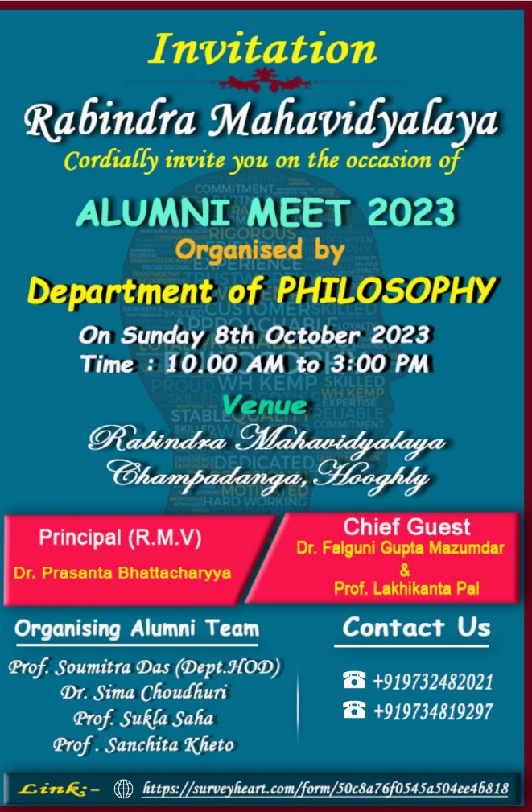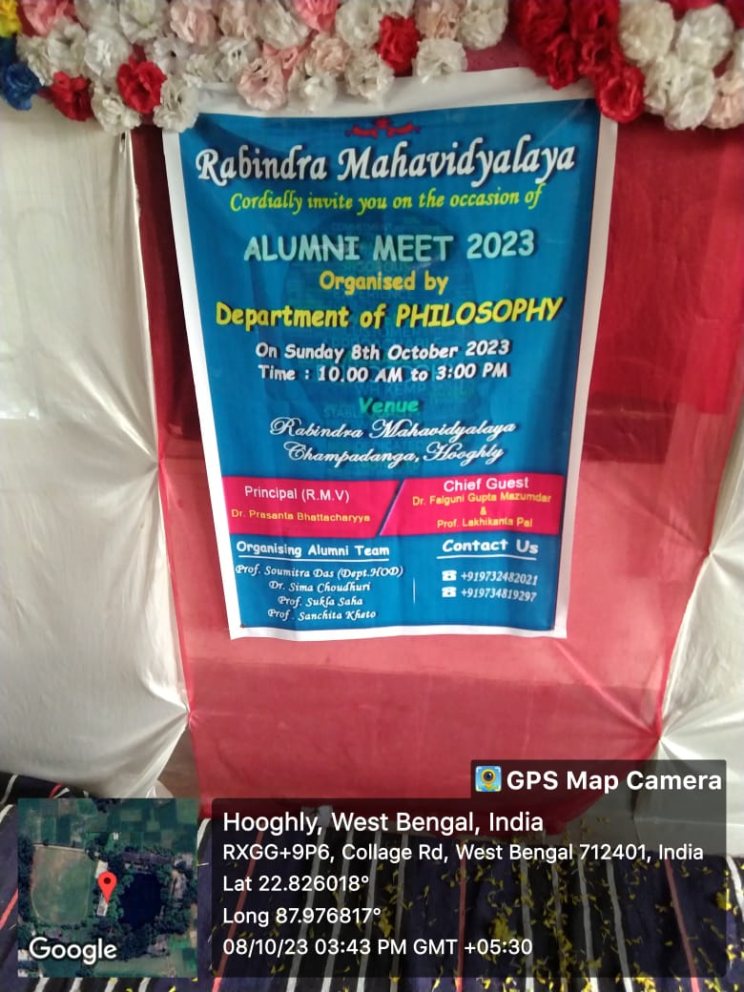

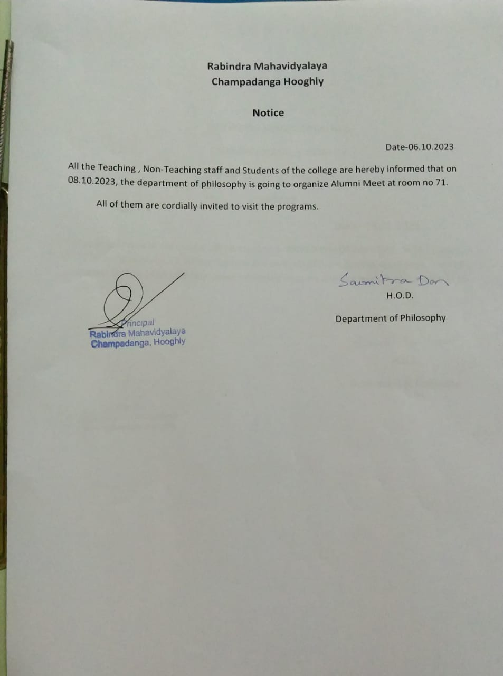

Summary

Alumni Meet Report:
--------------------------------
An alumni meet is organized by the Department of Philosophy on 8th October 2023. Dr. Falguni Gupta Majumdar and Prof. Lakhikanta Pal were present as chief guests on the occasion. Alumni attended 65.After a small tiffin our program started. At the beginning of the program, the chief guests did the lamp-lighting and students sang Sarasvati Bandana along with it. Chief guests are also honored with bouquet of flowers and uttariya (scarf). Various cultural events like song, dance, recitation etc. were held on that day.Alumni are felicitated with sandalwood drop, flowers and mementos. Many alumni present at the event are established in their own field or place and many are pursuing higher studies. Current students are encouraged to seeing this.

Alumni shared their experiences of their founding journey with the current students. They shared their collage memories with current or junior students. Current students have been able to be certain about their future. As a result of our communication with Alumni, we may be able to solve any problem they may have, this can be said to be an effort. Current students are encouraged to see that most of our alumni’s have established themselves in different places.

After lunch the program resumes. Apart from current students, alumni also performed on that day. Some alumni and some present students present a dance drama called ‘Anurakta Radha’. This dance drama performance impresses everyone very much. Thus, the day’s program was completed. Finally, our program ended with some constructive discussions with the alumni.

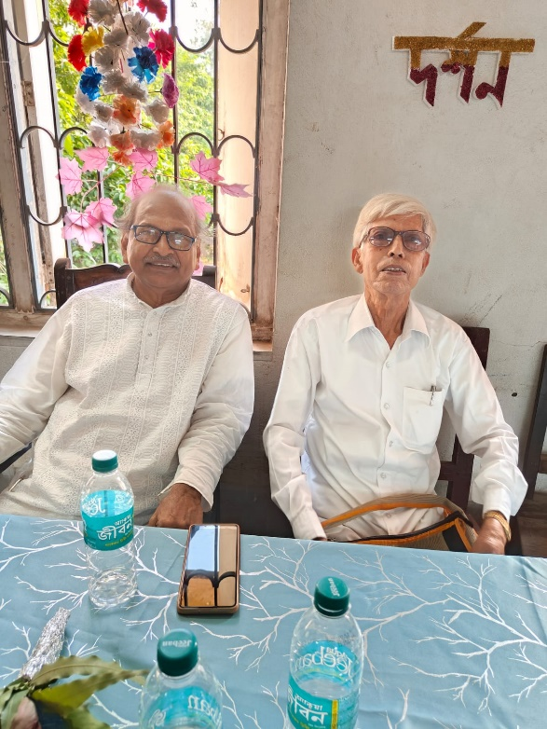
Our honorable chief guests
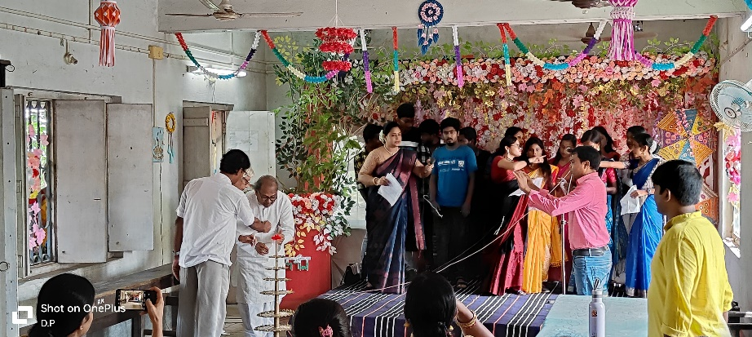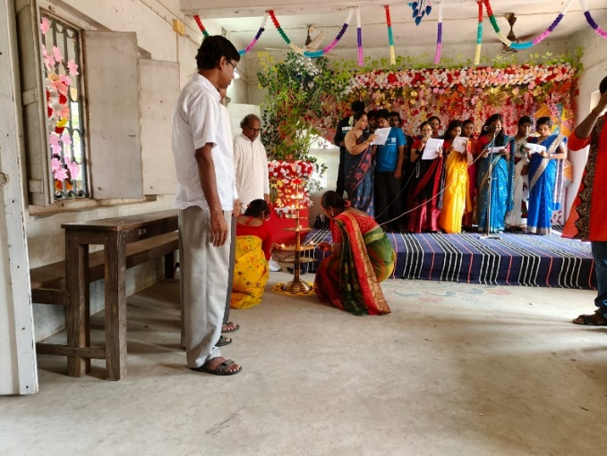
lamp-lighting by our chief guests

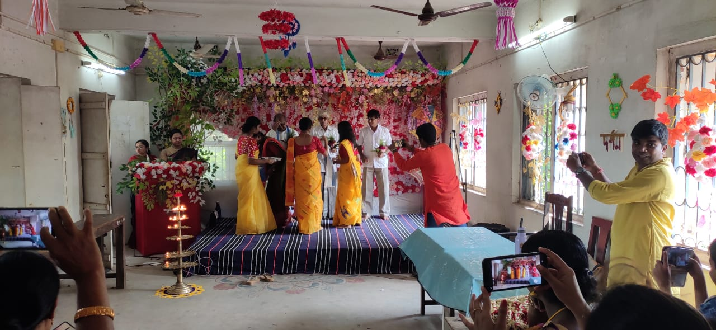
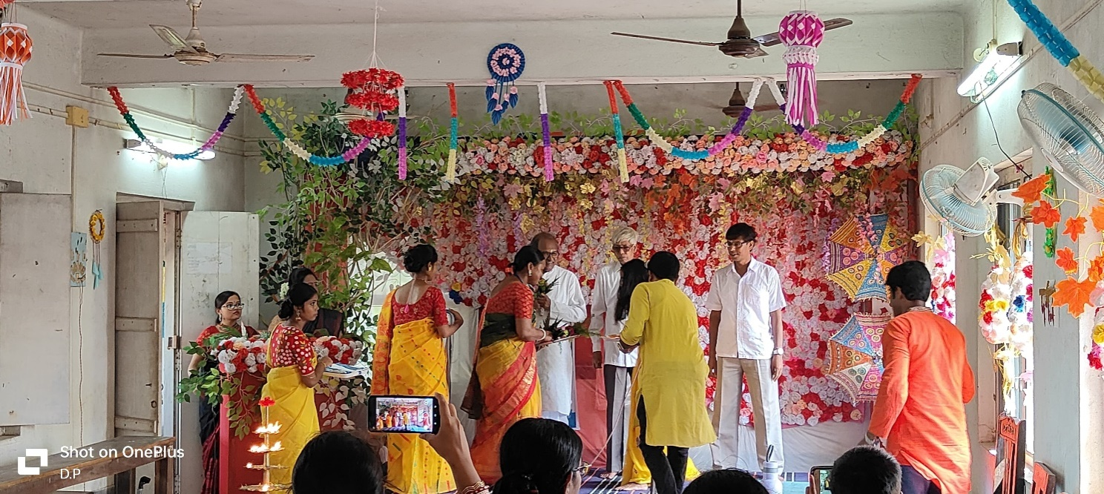
honored withbouquet of flowers and uttariya
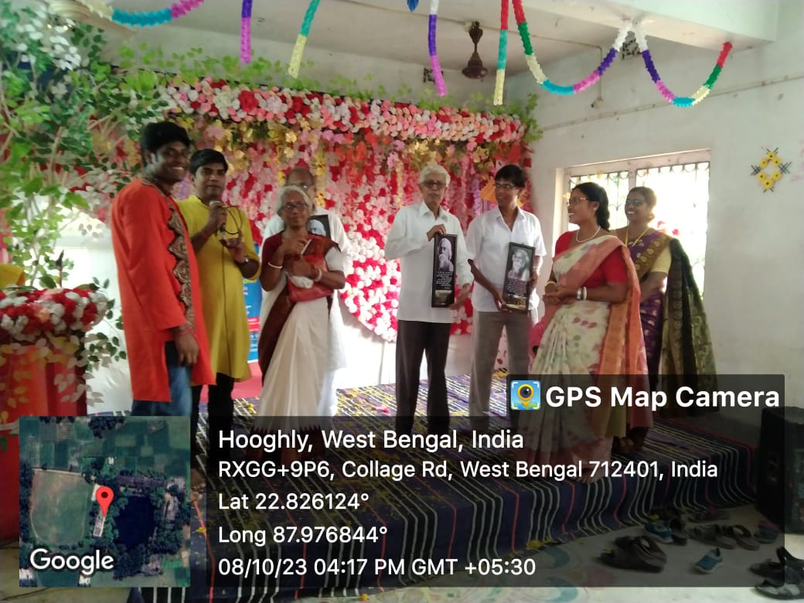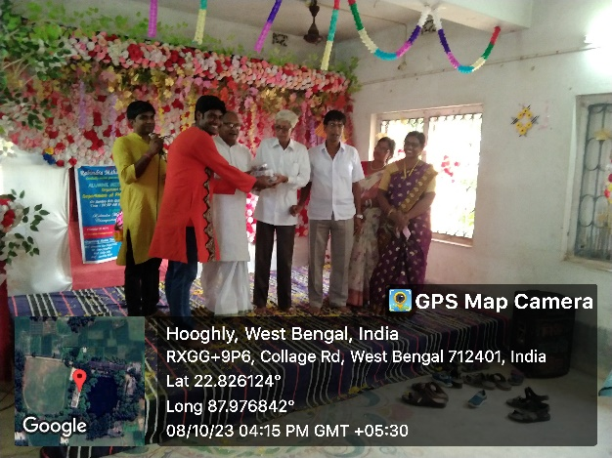
To honor the chief guest the alumni gave gifts
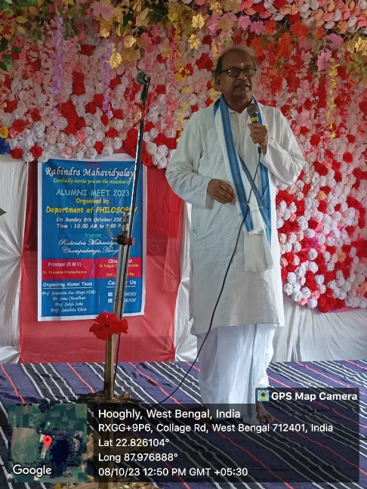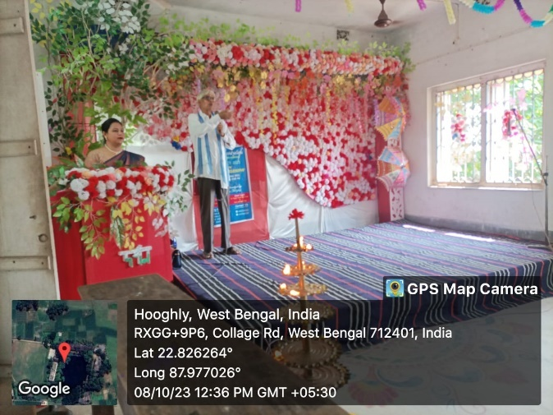
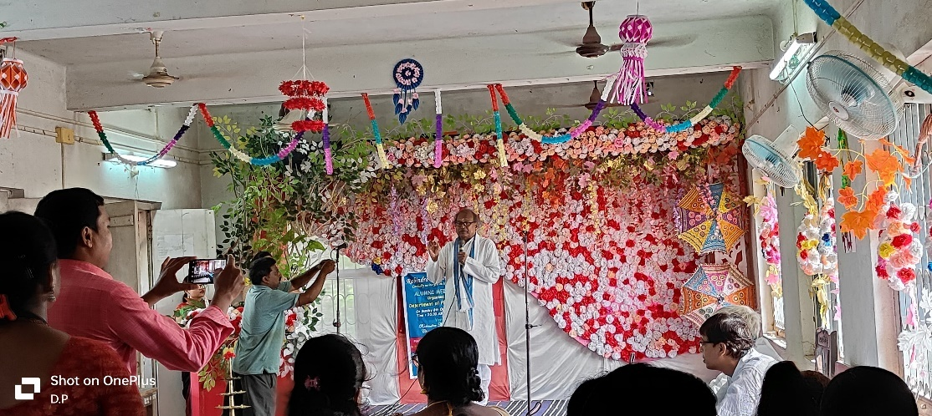
Inaugural speech by our chief guests

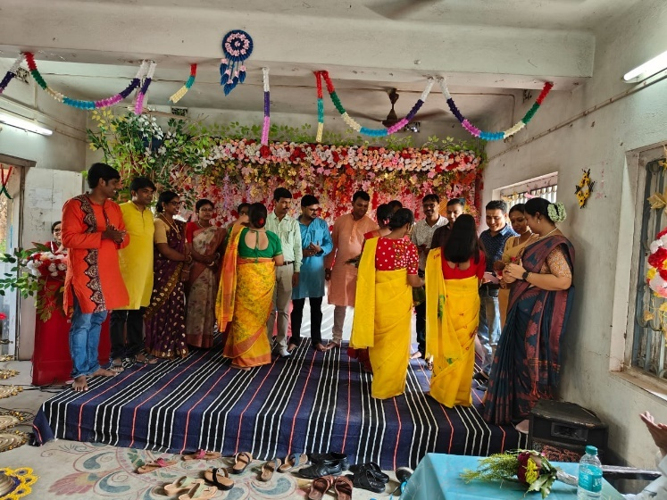
Our alumni felicitated with sandalwood, flowers and mementos

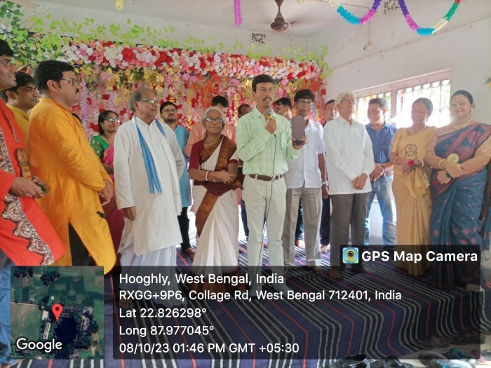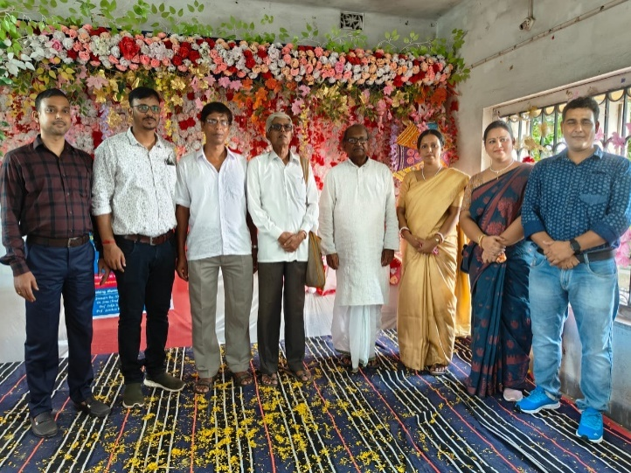
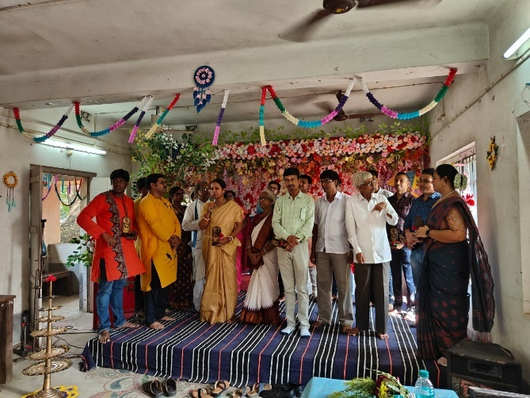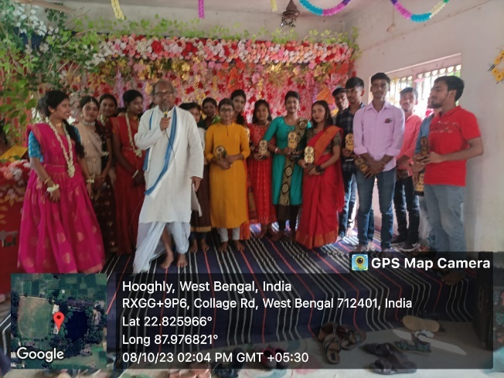
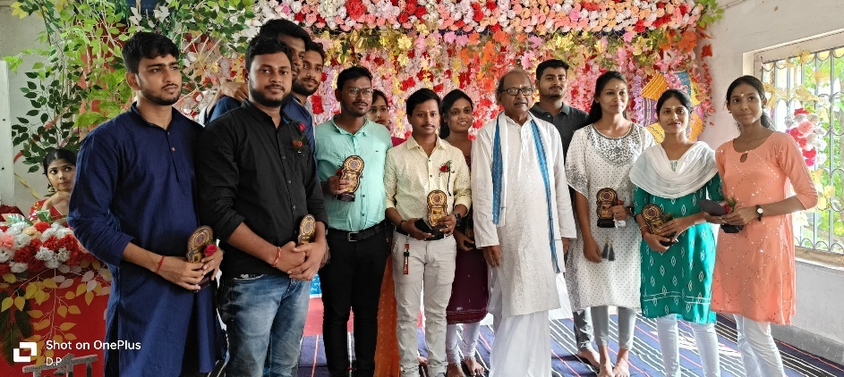
Our alumni’s

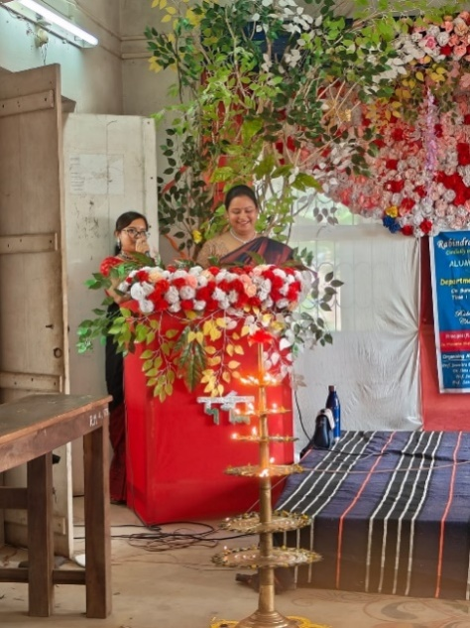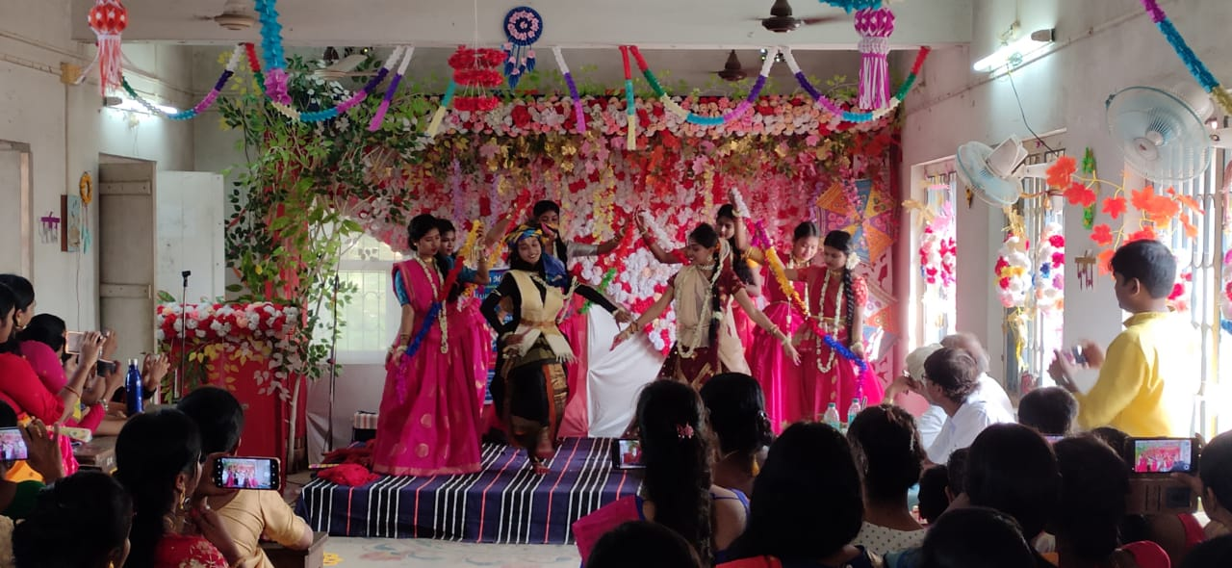
Event host
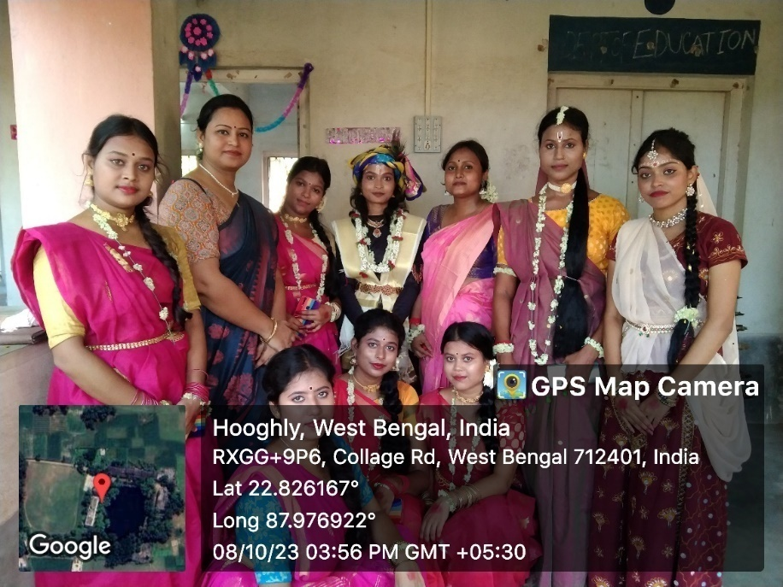
Team ANURAKTA RADHA

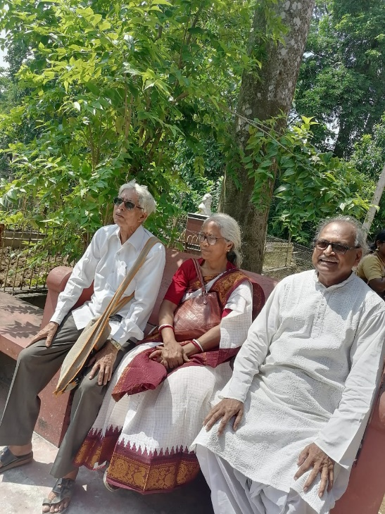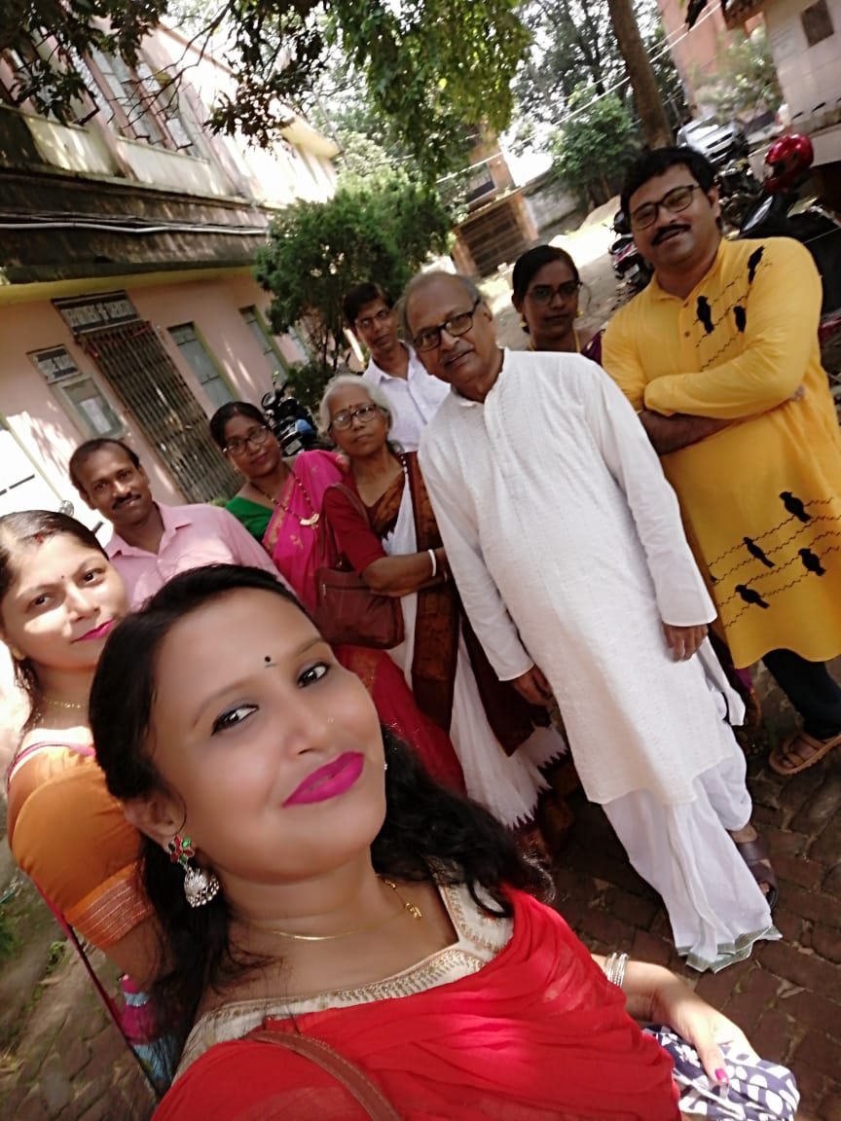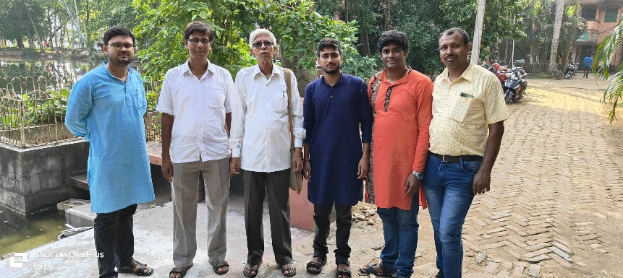
SOME GLIMPS
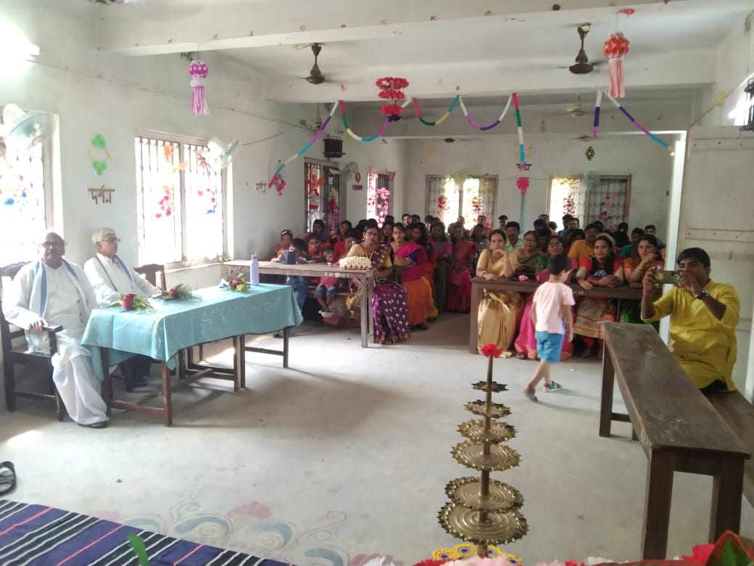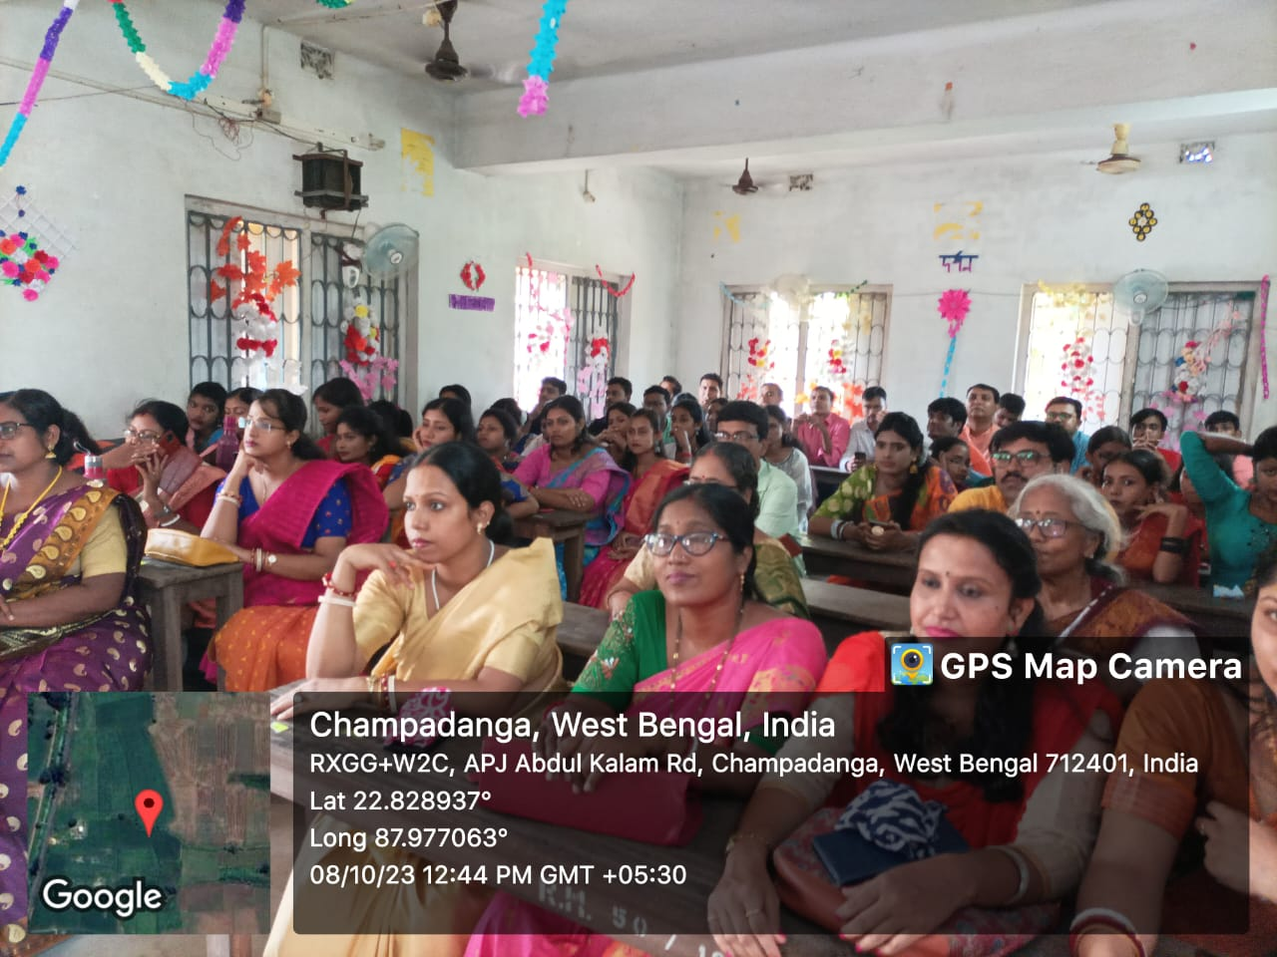
OUR AUDIENCE

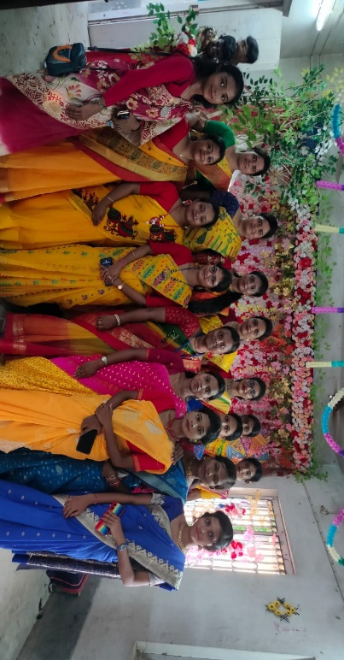
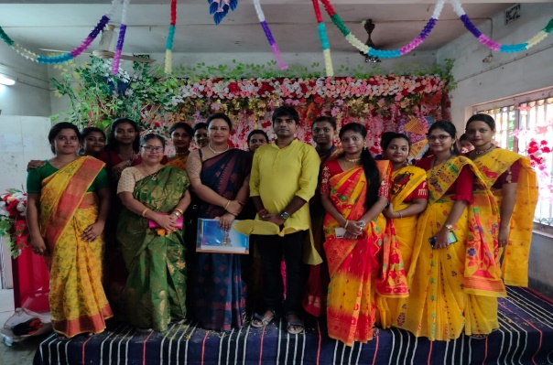OUR PRESENT STUDENTS

Attendance: 115
Male: 35
Female:80

Tentative programme schedule
- Registration desk 10.30a.m. to 11:30a.m.
- Inaugural session: 11.30a.m. to 11.45a.m.
- Inaugural speech:11.45a.m. to 12 noon
- Welcome to alumni: 12noon to 12:30 p.m.
- Alumni speech: 12.30 p.m. to 1.00 p.m.
- Lunch break: 1.00 p.m. to 1:30 p.m.
- Cultural programme: 1:30 p.m. to 4:30 p.m.

Registration sheets(offline):

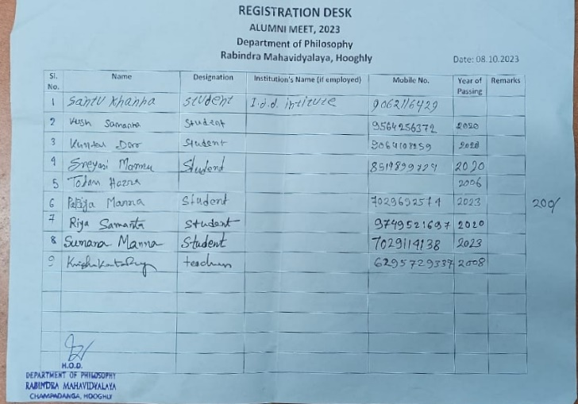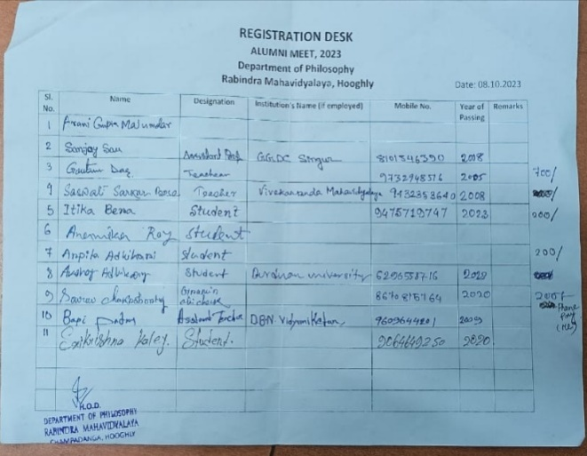
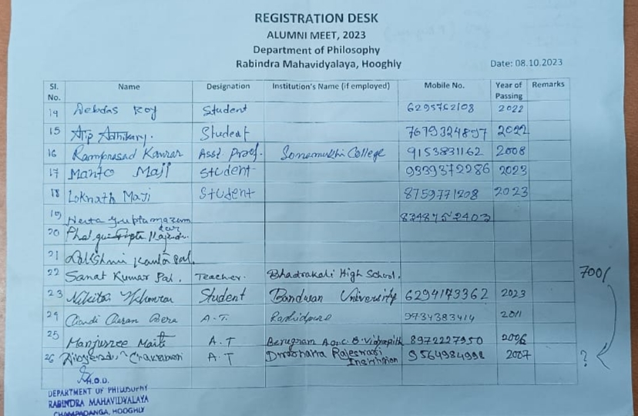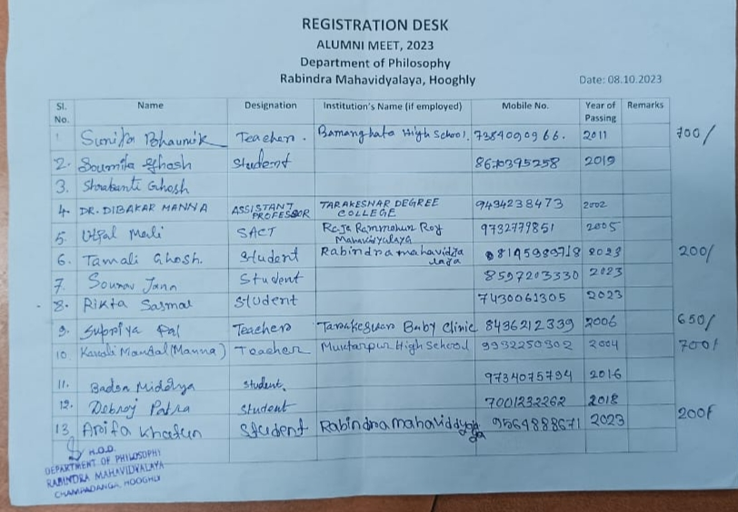
Registration sheet (online):
Registration Link is:https://drive.google.com/drive/folders/1eT9jZSKJYSAccPUAVI52EJo7992W6-3W

Feedback from alumni:

- suggested thinking about the program on a larger scale
- talk about forming a committee
- A Telegram Group was opened to run the activities of Alumni Association and tocommunicate with members;
- Our alumni assured us to help in their best way.
- Interacting with friends, senior, junior and teachers by sharing our past memories we enjoyed that day
- To see our department and our sir ma'am, they truly encourage us for our better future...They give very positive energy so that we can do something for our department.

